OIT-367 Regression Project

Predicting Commercial Success of Songs

Alex Wurm, Ben Chen,
Valerie Taruno, Vivian Barli

March 11, 2026

Executive Summary
- Problem
What makes a song a hit? Music label A&R (artists and repertoire) teams have grappled with this question for decades, but it is rarely examined through a rigorous, data-driven lens. This project explores what predicts commercial music success using Spotify audio features augmented with artist-level signals from the Spotify API and Last.fm. From a dataset of over 78,000 unique tracks (of which roughly 3% appeared on the Billboard Hot 100) we address two questions: what predicts whether a track reaches the chart, and among those that do, what predicts how long it stays.
- Principal Findings
Chart Entry: Artist popularity, not audio production, is what gets a song onto the Billboard Hot 100. An artist's historical peak popularity and listener base dominate every audio feature combined. Models using only audio characteristics perform barely better than random given how rare chart entry is. Once we incorporate artist-level features, our best model (XGBoost Decision Trees) can correctly predict the vast majority of eventual chart hits while only generating a small fraction of false negatives, a practical screening tool for music labels to allocate resources that dramatically narrows the funnel. Among audio signals, instrumentalness is the strongest barrier to charting, while higher valence, US artist origin, and explicit content provide modest independent advantages.
Chart Longevity: Genre and artist identity explain far more about how long a track stays on the Hot 100 than its audio features. Audio features alone account for roughly 5% of the variation in chart duration; adding genre and artist controls raises that to about 25%. A Cox survival model confirms that the streaming era has fundamentally compressed chart lifespans: tracks from more recent decades rotate off the chart significantly faster on a per-week basis than their predecessors. Louder tracks and those from artists with higher historical popularity tend to last longer, but even our richest models fail when asked to predict forward in time. Every model we tested performed worse than simply guessing the average when applied to songs released after 2015, indicating that what predicted chart staying power in the past does not carry over to future releases.
- Recommendations
Record labels should invest in understanding an artist's existing audience reach before evaluating their sound. Audio production matters at the margin, particularly avoiding overly instrumental or low-valence tracks, but artist platform presence is the primary driver of chart success. For chart entry screening, our model offers a tool to narrow the funnel of tracks worth closer evaluation, though given limitations about the efficacy of historical data, it should be used with caution, rather than replace A&R judgment.
For chart longevity, labels should not rely on predictive models to forecast how long a new release will chart. The music industry's rapid structural evolution through streaming platforms, playlist algorithms, and social media dynamics makes historical patterns unreliable guides to future performance. Instead, labels should use our descriptive findings directionally: expect shorter chart windows in the streaming era, and recognize that sustained chart presence is increasingly a function of promotion infrastructure and audience scale rather than song-level audio characteristics.

Introduction

The Billboard Hot 100 is the primary commercial benchmark of a song's commercial success in the United States, which combines radio, download, and streaming signals into a single weekly chart. Understanding the determinants of chart entry and longevity has significant commercial implications: record labels, streaming platforms, and artists spend billions of dollars annually on music production and promotion with limited ability to predict which attributes drive commercial success.

Recent developments in music streaming have created an unprecedented opportunity for data-driven analysis. Spotify's audio feature API provides quantifiable acoustic descriptors, such as valence, instrumentalness, danceability, tempo, and others, for over 100 million tracks. These features, combined with artist popularity metrics, offer a rich basis for modeling song chart success.

This project addresses two specific research questions:
Chart Entry: Which audio features and song attributes predict whether a track reaches the Hot 100?
Chart Longevity: Among tracks that chart, which features predict how long they remain on the Hot 100?

Data

2.1 Sources and Feature Selection
We created the base dataset by integrating the Spotify Tracks Dataset with Billboard Hot 100 snapshots (1958-2024), joined via unique Spotify track IDs. We augmented this dataset with artist-level signals from the Spotify Web API (historical popularity and catalog size) and log-transformed listener counts from MusicBrainz/Last.fm to account for heavy right skew.

For a subset of 856 out of 2,157 charted tracks, we incorporated VADER sentiment scores derived from song lyrics. To ensure model stability, we removed energy, danceability, and tempo after observing Correlation Matrix patterns (see Figure 1 for final matrix) and Variance Inflation Factors (VIF) exceeding 10. The final classification set comprises 15 features: 10 Spotify audio metrics and 5 artist-level commercial signals. Longevity models further include a decade index and lyric sentiment features (Full VIF details and feature definitions are provided in the Appendix).

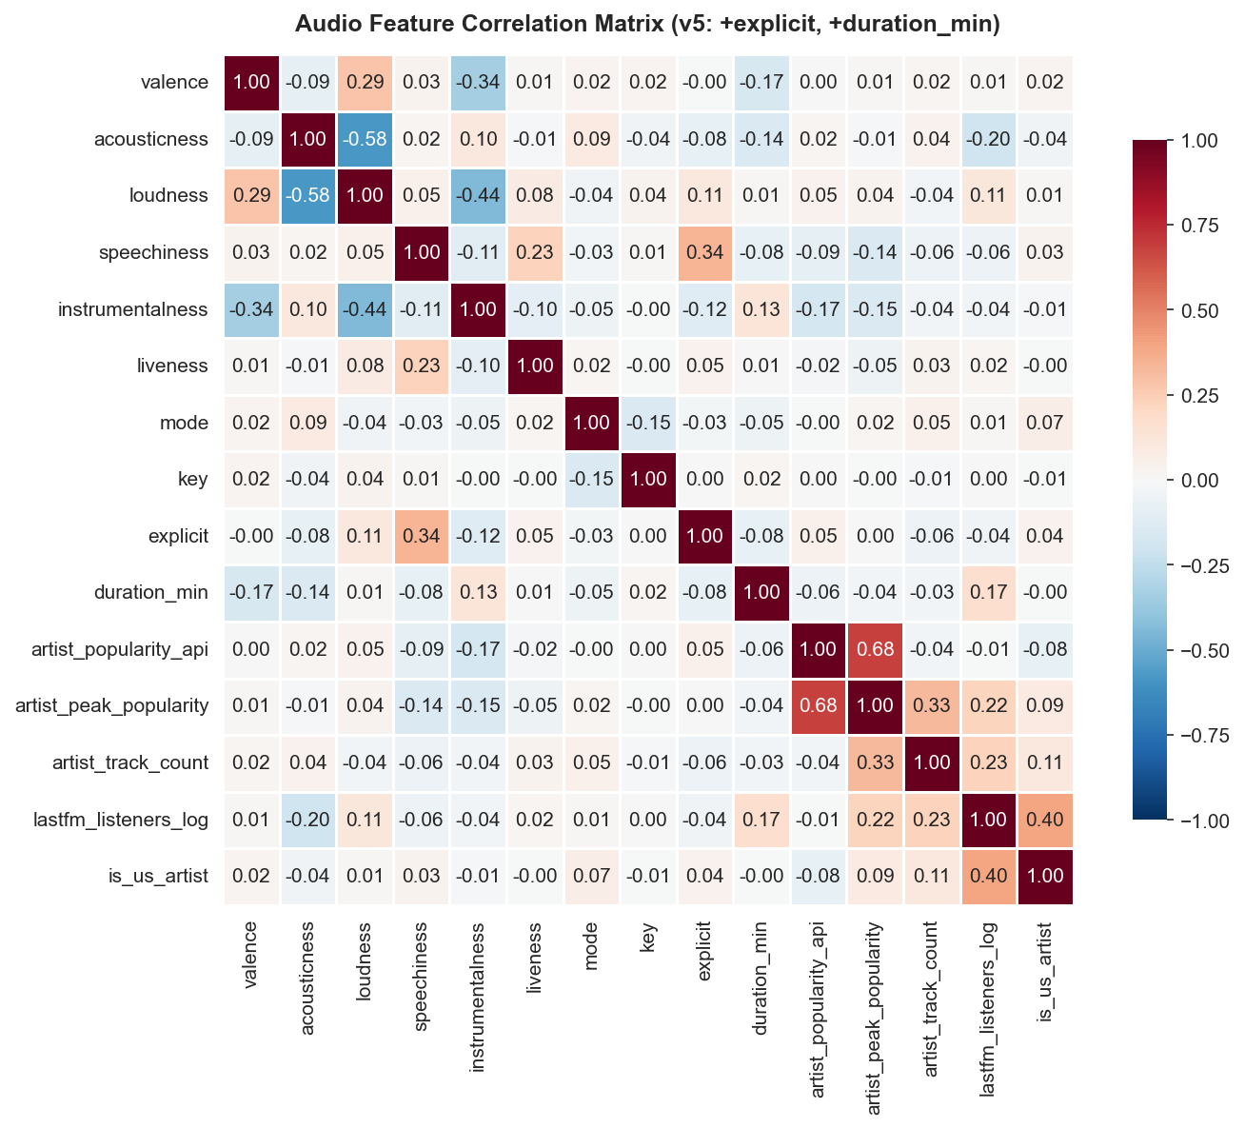
Figure 1: Audio Feature Correlation Matrix

2.2 Dataset Construction and Handling Imbalance
We used a data cleaning pipeline to deduplicate tracks to a single row per ID, resulting in a total of 78,390 unique songs. A left join with Billboard history identified 2,157 charted tracks (2.75% positive rate). This inherent class imbalance (illustrated in Figure 2) makes Precision-Recall AUC (PR-AUC) our primary evaluation metric. While ROC-AUC can be misleadingly optimistic by over-weighting the model’s ability to correctly identify the vast majority of non-charted tracks, PR-AUC focuses specifically on the "charted" minority class. It provides a more rigorous measure of the model's ability to minimize false positives in an environment where a random classifier achieves a baseline of only 0.0275. See Appendix for full data cleaning pipeline.

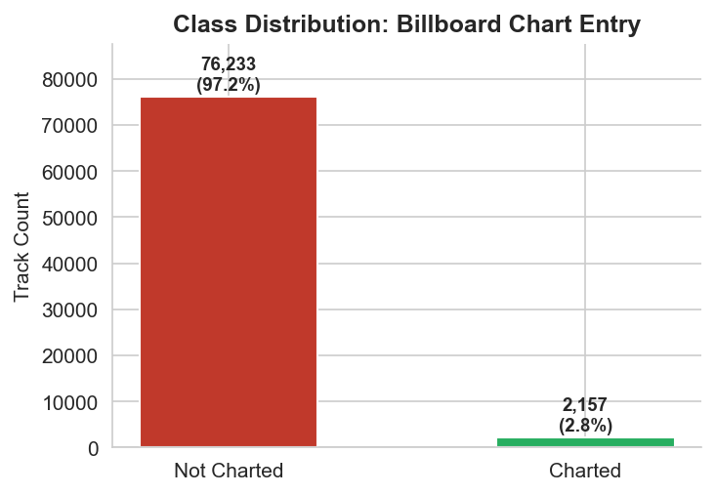
Figure 2: Class Distribution (Charted vs. Not Charted Tracks)

Methods

3.1 Classification: Chart Entry (RQ1)
To model chart entry, we utilized a stratified 80/20 train-test split. We first established a Logistic Regression baseline to derive standardized coefficients and odds ratios for stakeholder interpretability. To capture nonlinearities and feature interactions, we implemented XGBoost 2.1.3, utilizing the SHAP (SHapley Additive exPlanations) framework to rank feature importance (see Figure 3 for final feature importance distribution). We addressed class imbalance via weighted loss functions in both models. We also trained audio-only baselines to isolate the marginal predictive lift provided by artist enrichment features. Addition of artist features was critical for achieving strong performance in classification (see Figure 4 for comparative performance over baseline).

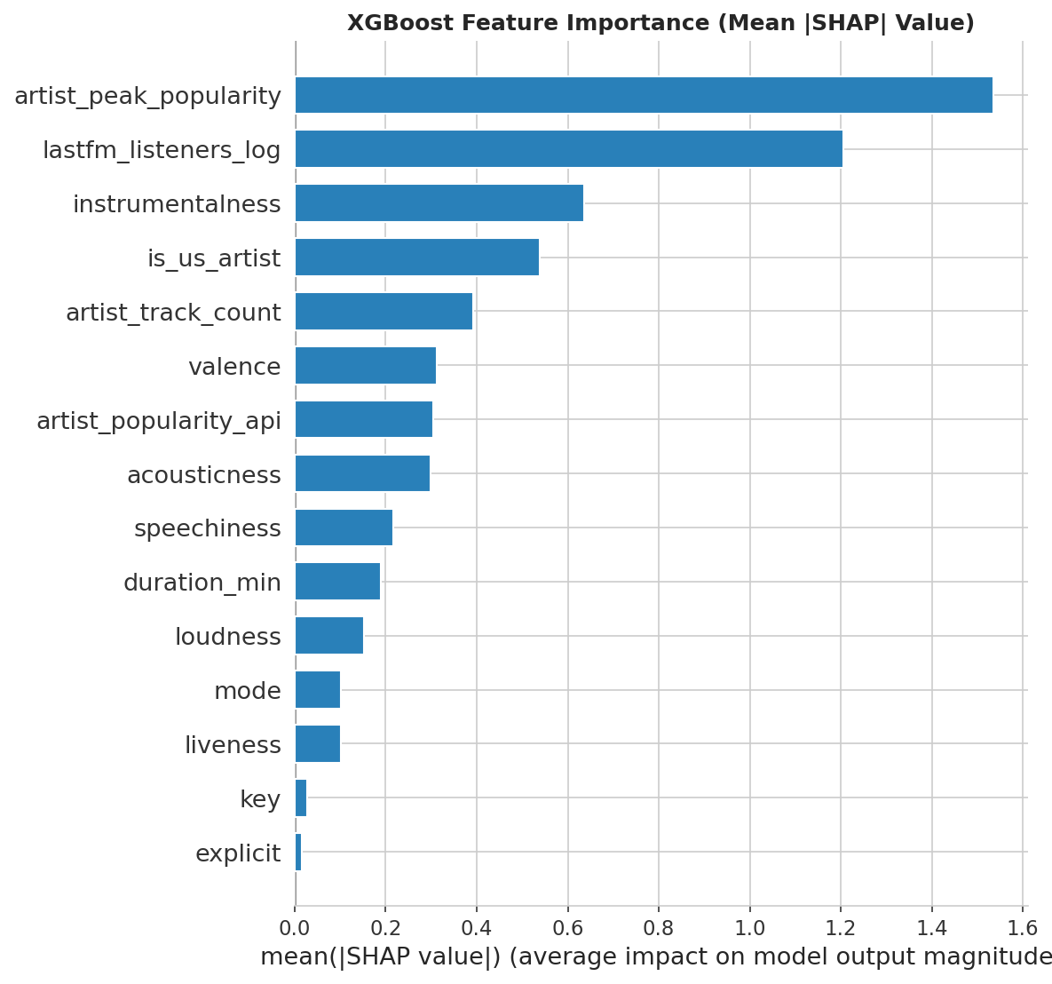
Figure 3: SHAP Feature Importance Distribution

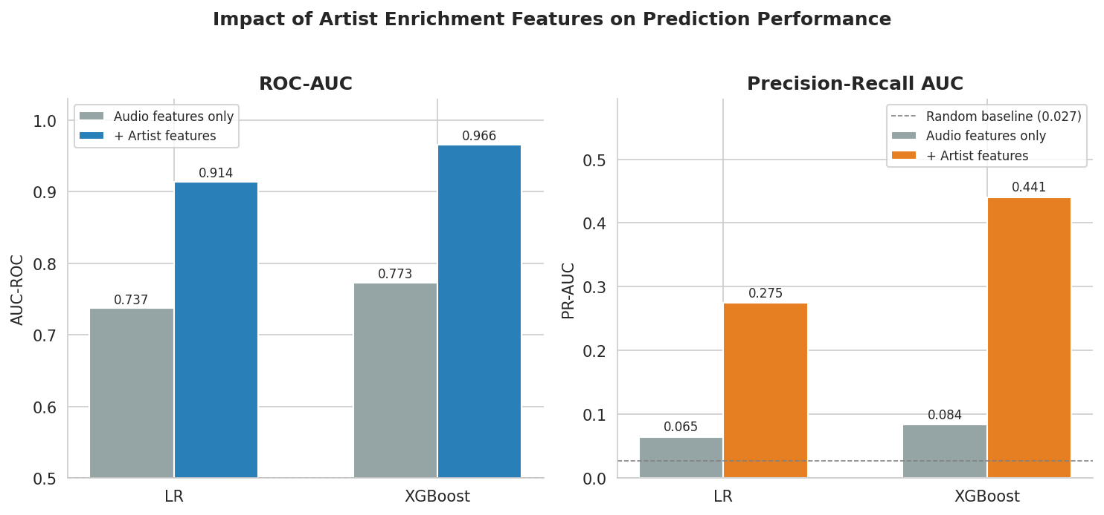
Figure 4: Comparative Performance of Audio-Only vs. Artist-Feature-Enriched Model

3.2 Survival Analysis: Chart Longevity (RQ2)
We modeled longevity – defined as weeks on the Hot 100 – using a Log-OLS regression. By regressing the logarithm of weeks on the chart (log1p[wks_on_chart]), we corrected for the heavy right-skew of the raw data, where a small number of "mega-hits" stay on the chart far longer than the average song.

As a robustness check, we compared regression results using a Cox Proportional Hazards (Cox PH) model to account for right-censoring in the chart data. We verified the proportional hazards assumption using Schoenfeld residuals (see Appendix). Because the "mode" variable (major vs. minor key) violated this assumption, we utilized a stratified model. This approach allowed the baseline exit risk to differ by musical modality without forcing an identical effect over the entire seven-decade dataset. Comparing these two models allows us to distinguish true structural findings from statistical artifacts.

Results

4.1 Research Question 1: Chart Entry Classification

Which audio features and song attributes predict whether a track reaches the Hot 100?

Two machine learning models: logistic regression and XGBoost, were trained on a dataset of 62,712 tracks and validated against a dataset of 15,678 tracks to predict whether a track would enter the Billboard Hot 100. Features spanned both artist profile (popularity scores, listener counts, catalog depth) and audio characteristics (valence, tempo, acousticness, instrumentalness, and others). Models were evaluated on a held-out test set using AUC-ROC, average precision, and a decision threshold analysis that translates model scores into practical record label screening recommendations.
Finding 1: Who releases the song matters more than the song itself. Artist peak popularity and Last.fm listener count are the two strongest predictors of chart entry. An established artist with a large existing audience starts with a significant structural advantage before a single note is evaluated.

Finding 2: Emotionally positive, vocal tracks chart more. High valence increases chart odds meaningfully, and instrumentalness is the strongest negative audio signal. The Billboard Hot 100 is a chart built around vocal pop and hip-hop, and the model reflects that.

Finding 3: Being a US artist independently boosts chart odds. The Billboard Hot 100 has a well-documented bias toward domestic artists and US radio markets, and the model picks this up clearly.

Figure 5 shows the true positive rate (fraction of actual chart hits correctly identified) against the false positive rate (fraction of non-charting tracks incorrectly flagged) for logistic regression (blue, AUC = 0.914), XGBoost (orange, AUC = 0.966), and a random classifier baseline (black dashed, AUC = 0.500).
Both curves shoot steeply upward from the origin, which is good because it means both models recover a large share of genuine chart hits while keeping false positives low. A record label company will not have time to review too many songs as they want to come up with a small list and be confident that they contain most of the hits. XGBoost performs better (5.2 point) than logistic regression model, which shows meaningful non-linearity between the predictive features and the outcome of whether or not a song will chart. For example, the interaction between one artist feature and audio feature may predict chart entry disproportionately than each of this feature individually, in a way that linear model underweights.
Having said that, an average precision of 0.275 from logistic regression is still well above the 0.027 random baseline, and the model remains valuable for a different reason. While XGBoost is the better screening tool, logistic regression is more interpretable and can tell us which features need to be highlighted to boost a song's probability of charting — something XGBoost cannot offer as cleanly.
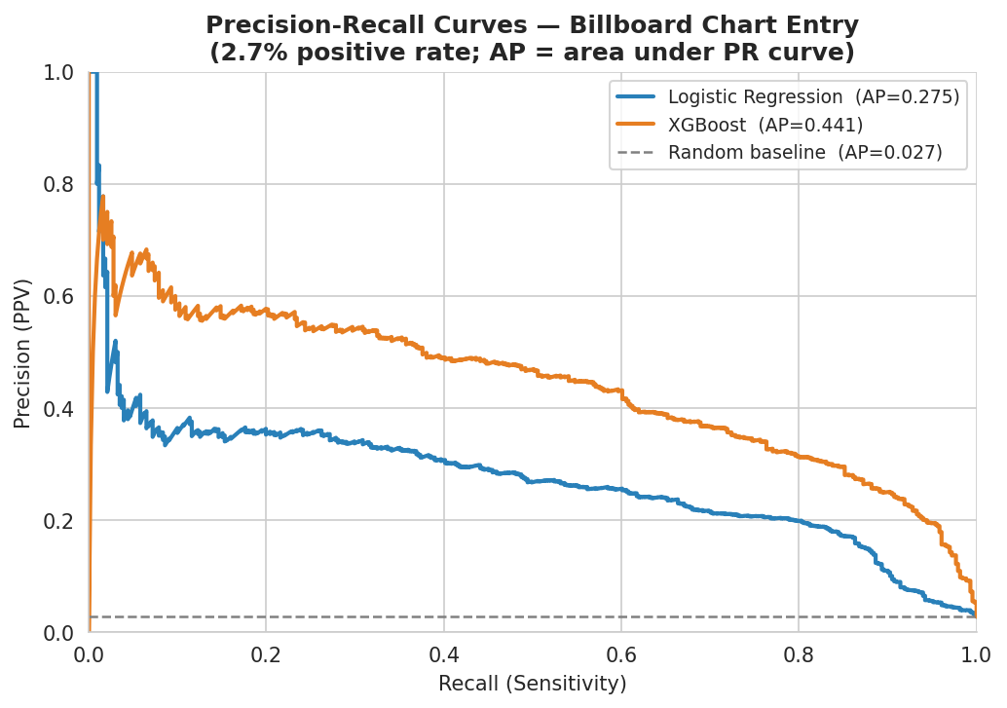
Figure 5: Precision-recall curves for both classifiers. The random baseline (gray dashed) lies at PR-AUC = 0.0275, corresponding to the 2.75% positive rate. XGBoost achieves 16-fold lift.

Figure 6 shows the true positive rate (fraction of actual chart hits correctly identified) against the false positive rate (fraction of non-charting tracks incorrectly flagged) for logistic regression (blue, AUC = 0.914), XGBoost (orange, AUC = 0.966), and a random classifier baseline (black dashed, AUC = 0.500).
Both curves shoot steeply upward from the origin, which is good because it means both models recover a large share of genuine chart hits while keeping false positives low. A record label company will not have time to review too many songs as they want to come up with a small list and be confident that they contain most of the hits. XGBoost performs better (5.2 point) than logistic regression model, which shows meaningful non-linearity between the predictive features and the outcome of whether or not a song will chart. For example, the interaction between one artist feature and audio feature may predict chart entry disproportionately than each of this feature individually, in a way that linear model underweights.
Having said that, an AUC of 0.914 from the logistic regression model is very strong in and of itself. While XGBoost can be a good tool to screen the songs, the regression model is more interpretable and can give us information on which feature needs to be highlighted more to boost probability of a song charting.

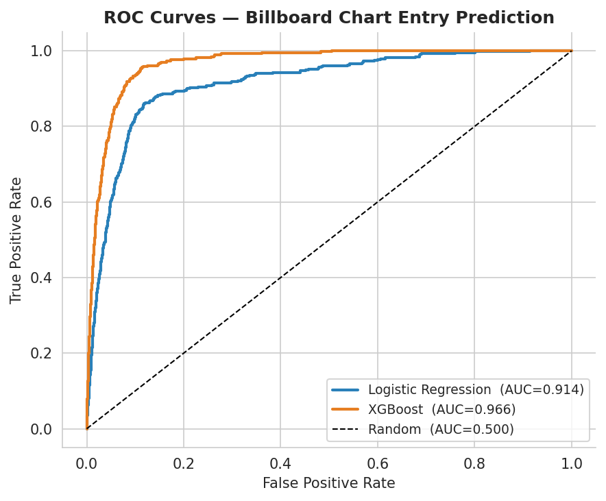

Figure 6: ROC curves for logistic regression (AUC = 0.914) and XGBoost (AUC = 0.966) on the held-out test set.
Figure 7 ranks all 15 features by their odds ratio per one standard deviation increase, showing how much each feature shifts the probability of chart entry, and in which direction. Bars to the right of 1.0 increase the odds; bars to the left decrease them.
The most immediate takeaway is the two-tier structure of the chart. The top two features: artist_peak_popularity (OR ≈ 2.8) and lastfm_listeners_log (OR ≈ 2.15), are substantially larger than everything below them, and together they dwarf the entire audio feature set combined. These are both measures of how commercially established an artist already is. This continues to emphasise that before we even look at what a song sounds like, the model is already heavily weighing whether the artist releasing it has a proven audience.
Is_us_artist (OR ≈ 1.9) comes in third, reflecting the Billboard Hot 100's well-documented structural bias toward domestic artists and US radio markets. Among the audio features, valence (OR ≈ 1.4) is the strongest positive signal, as happier, more emotionally positive tracks are more likely to chart, followed modestly by explicit content and mode.
On the negative side, instrumentalness has the largest downward effect, sitting well below 1.0. Tracks that are primarily instrumental are much less likely to chart on the Hot 100, which is a chart built around vocal pop and hip-hop. Speechiness, liveness, and acousticness all reduce chart odds modestly, while key sits essentially flat at 1.0 — the musical key a song is in carries almost no predictive signal.
The practical message for a label is the same one that runs through this entire analysis: invest in understanding an artist's existing audience before evaluating their sound. The sound matters at the margin, but the audience is what the model is really detecting.

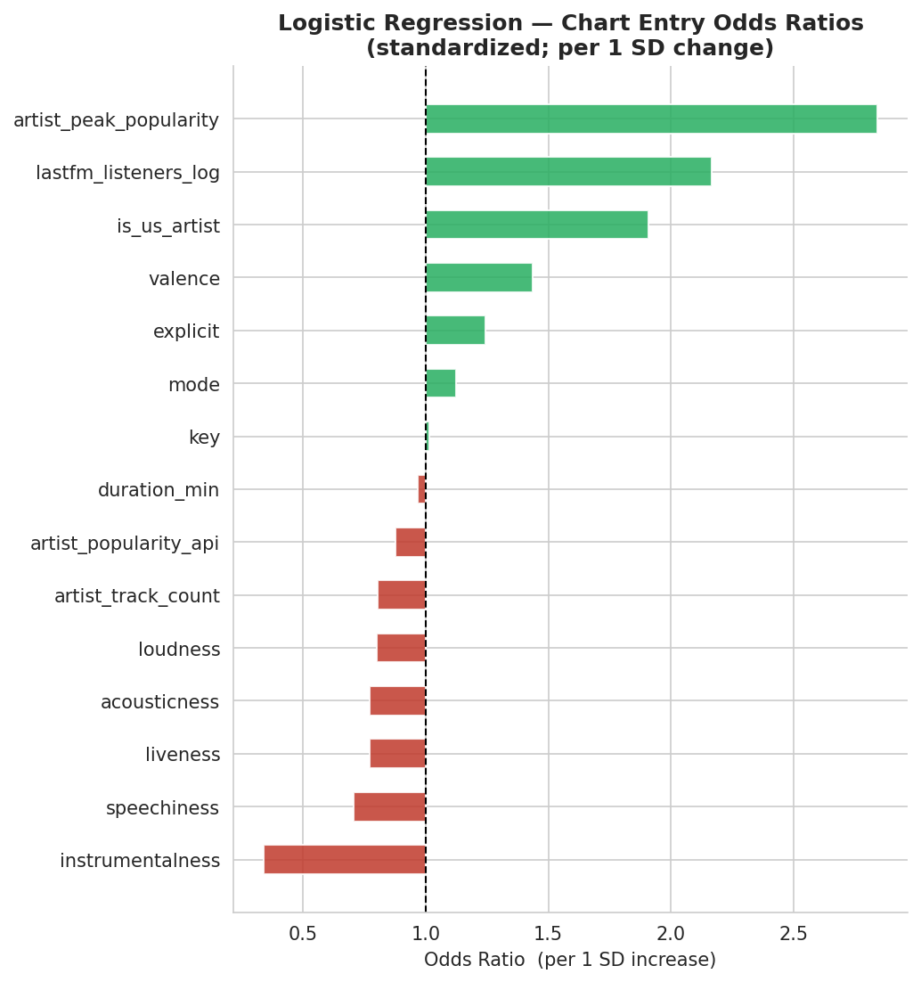
Figure 7: Audio and artist features on logistic regression model

4.2 Research Question 2: Chart Longevity
Among tracks that chart, which features predict how long they remain on the Hot 100?
We modeled log(weeks_on_chart) for Billboard Hot 100 songs using OLS regression, progressively enriching our feature set, then validated findings with a Cox proportional hazards survival framework.
Finding 1: Audio features alone explain very little. Our initial hypothesis was that the “musicality” (audio features) of a song may explain success. Our baseline OLS used 14 Spotify audio features to predict log weeks_on_chart for 2,157 songs. Though jointly significant (p < 0.001), the model explained only ~5% of variance (R² = 0.047). More danceable, longer, and major-key tracks stayed longer, while higher speechiness, acousticness, and instrumentalness predicted shorter runs. The Cox baseline concordance of 0.551 similarly shows audio features alone barely outperform chance at discriminating short- from long-charting tracks. This finding led us to pursue other features, including genre and artist.
Finding 2: Genre and artist identity are the dominant drivers. Adding genre dummies raised R² from 0.05 to 0.27, indicating genre captures audience segments, radio formats, and playlist dynamics that audio alone cannot. Adding artist-level controls (followers, monthly listeners, Last.fm scrobbles) yielded R² ≈ 0.15 without genre and R² ≈ 0.23 with genre included. In our richest specification, which incorporated sentiment, lyric features, and additional artist metadata on 512 songs, R² reached 0.24, though sentiment and lyric variables contributed almost no incremental signal in the linear framework.
Finding 3: Cox survival model confirms and extends these findings. The Cox proportional hazards model achieves a concordance index of 0.753 on 856 lyric-matched charted tracks, substantially outperforming the audio-only baseline. The strongest predictor is decade_idx (HR = 0.514, p < 0.001): each additional decade corresponds to a 49% increase in per-week exit hazard, confirming that streaming-era tracks rotate off charts faster on a per-song basis.
Figure 7: Kaplan-Meier Survival Curves by Genre
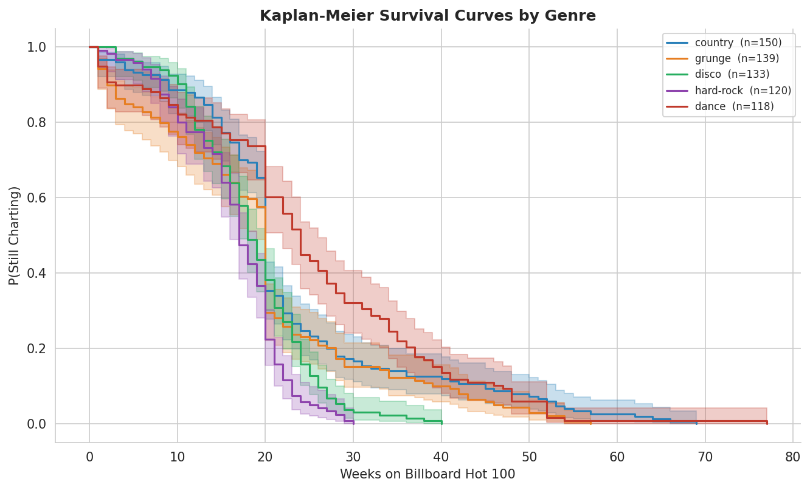
Figure 8: Kaplan-Meier Survival Curves by Genre
The probability of remaining on the chart declines sharply in the first 10 weeks, with genre-level differences reflecting format and rotational differences across radio markets.
Among artist features, historical peak popularity (HR = 0.835, p < 0.001) predicts longer runs, while larger catalog size (HR = 1.115, p = 0.005) and higher current API popularity (HR = 1.085, p = 0.030) also reach significance, suggesting active label promotion sustains chart position beyond audio characteristics alone. Loudness is the only significant audio feature (HR = 0.900, p = 0.012). Four covariates fail the Schoenfeld test for proportional hazards (decade index, acousticness, duration, positive sentiment), though the directional consistency between Cox and OLS for decade index provides robustness evidence.
Finding 4: Models do not generalize forward in time. We evaluated all OLS specifications using temporal train-test splits (cutoffs at 2015 and 2019). Every model produced negative out-of-time R² – performing worse than predicting the mean for all future songs. The richest in-sample model (R² = 0.48) achieved a test R² of -0.32. This is consistent with the Cox model's decade-index finding: the music industry's structural evolutions (changing streaming platforms, playlist algorithms, and consumption patterns) means historical feature-outcome relationships do not extrapolate reliably to future releases.
These models tell us that artist reach and genre dominate chart longevity, and streaming has fundamentally accelerated chart turnover. But they should not be used as forecasting tools for new releases.

Conclusions
Our song charting analysis revealed several key insights regarding the likelihood of a song reaching the Billboard Hot 100 and its expected longevity on the charts:
- Audio features are minimally predictive of songs’ odds of charting on the Billboard Hot 100
- Primarily artist popularity, and secondarily genre, most influence Billboard Hot 100 charting
- Billboard Hot 100 charting is biased toward domestic U.S. artists
- All factors influencing charting longevity have seen absolute correlation decrease over time
To better understand the likelihood of commercial success, record labels should understand an artist's existing audience before evaluating their sound. Audio features barely outperform random at a 2.75% positive rate when stripped of artist context. Of the audio signals that do matter, avoiding highly instrumental production and producing emotionally upbeat, vocal-forward material would increase probability of chart success, but these are second-order effects compared to the artist's existing popularity.
Furthermore, streaming has compressed chart lifespans by roughly half since the 1980s. Genre and artist identity dominate how long a song stays on the chart, but streaming has dramatically accelerated chart turnover, with each additional decade corresponding to a 49% increase in per-week exit hazard. The Cox model confirms decade index as the only predictor consistent across all specifications., and while genre and artist identity explain meaningful variance in-sample, no model generalizes to future releases – suggesting the factors driving chart longevity are shifting faster than historical data can capture.
The takeaway for a label is that high volume output of songs by popular artists is more likely to net greater overall time on the Billboard Hot 100 than a smaller number of ‘higher-quality’ songs. The structural evolution of music listening to a streaming-first environment has effectively reduced societal attention spans, and stronger commercial partnerships and better marketing are more important than ever.
Our findings are bounded by the inability to observe real-time streaming and playlist dynamics that may better predict song success (what else listeners are listening to at a given time, what other songs are charting in previous weeks, etc.) and our data limitation to US charts. Two directions would meaningfully extend this work. First, incorporating real-time playlist placement and streaming velocity data would directly address the failure to predict future releases. Second, extending the framework to international charts such as the UK Singles Chart would test whether the US artist origin effect reflects genuine market structure or is an artifact of building models on a US-domestic chart.
We grant permission for this project to be kept and used as an example for future classes.

Appendix

References
The following sources were used in this analysis. All Kaggle datasets are public and available without registration for download.
[1] Maharshipandya. (2023). Spotify Tracks Dataset. Kaggle. https://www.kaggle.com/datasets/maharshipandya/-spotify-tracks-dataset
[2] Earhart, E. (2024). Billboard Hot 100 (1958–2024). Kaggle. https://www.kaggle.com/datasets/elizabethearhart/billboard-hot-1001958-2024
[3] Rozenberg, R. (2022). Lyrics for Billboard Top 100 Songs 1946–2022. Kaggle. https://www.kaggle.com/datasets/rhaamrozenberg/billboards-top-100-song-1946-to-2022-lyrics
[4] pieca111. (2020). Music Artists Popularity (MusicBrainz / Last.fm). Kaggle. https://www.kaggle.com/datasets/pieca111/music-artists-popularity
[5] Spotify. (2024). Spotify Web Developer API — Artist and Track Endpoints. https://developer.spotify.com/documentation/web-api
[6] Hutto, C. J., & Gilbert, E. (2014). VADER: A Parsimonious Rule-Based Model for Sentiment Analysis of Social Media Text. Proceedings of the Eighth International AAAI Conference on Weblogs and Social Media (ICWSM-14).
[7] Guo, J., et al. (2025). Beyond the Hook: Predicting Billboard Hot 100 Chart Inclusion with Machine Learning from Streaming, Audio Signals, and Perceptual Features. arXiv preprint arXiv:2509.24856.
[8] Pachet, F., & Roy, P. (2008). Hit Song Science Is Not Yet a Science. Proceedings of the International Society for Music Information Retrieval Conference (ISMIR 2008).

Data cleaning pipeline

Data cleaning step | Number of tracks | Questions Addressed Using this Dataset
Base dataset with audio features | 114,000 tracks from Spotify dataset | -
Removing duplicates | 78,390 unique tracks | Q1
Adding artist features | 61,871 unique tracks with artist features | Q1
Joining with Billboard Hot 100 | 2,157 charted tracks | Q1, Q2
Adding artist features | 1,251 charted tracks with artist features | Q2
Added sentiment/lyric features | 856 charted tracks with artist + sentiment/lyric features | Q2

Variable Definitions

Table X.X: Model Feature Definitions
All features listed below are those used in at least one model in the final v6 pipeline. Audio features are sourced from the Spotify Tracks Dataset; artist-level features from the Spotify Web Developer API and the Music Artists Popularity dataset; temporal and sentiment features are derived variables.
Feature | Type / Range | Model(s) Used | Definition
valence | [0, 1] | All | Spotify's measure of musical positiveness. High values correspond to happy, euphoric, or uplifting tracks; low values to sad, angry, or tense tracks.
acousticness | [0, 1] | All | Confidence score (0–1) that the track was recorded acoustically rather than electronically produced. Derived from Spotify's audio analysis.
loudness | dB (~−60 to 0) | All | Overall average loudness of the track in decibels (LUFS). Values closer to 0 indicate louder tracks. Negative by convention.
speechiness | [0, 1] | All | Presence of spoken words. Values above 0.66 indicate speech-dominated content; below 0.33 indicate music with no speech; 0.33–0.66 indicate mixed content (e.g., rap).
instrumentalness | [0, 1] | All | Probability that the track contains no vocal content. Values above 0.5 are classified as instrumental. The dominant audio barrier to chart entry (OR = 0.34, SHAP = 0.629).
liveness | [0, 1] | All | Probability that the track was recorded in front of a live audience. Higher values suggest a live performance recording.
mode | 0 or 1 | All (stratum in Cox) | Musical modality. 1 = major key; 0 = minor key. Used as a stratification variable in Cox PH because it fails the Schoenfeld proportional hazards test.
key | 0–11 | All | Pitch class of the track using standard Pitch Class notation (0 = C, 1 = C#/D♭, …, 11 = B). Treated as a linear numeric feature; circular embedding was not applied.
explicit | 0 or 1 | All | Whether the track has an explicit content flag on Spotify. 1 = explicit; 0 = clean. Explicit tracks are 24% more likely to chart per the logistic regression odds ratio.
duration_min | minutes (capped 10) | All | Track duration in minutes, derived from duration_ms / 60000. Capped at 10 minutes to exclude podcast episodes and audiobook entries present in the Kaggle source.
artist_peak_popularity | 0–100 | All | Historical peak Spotify popularity score for the track's primary artist, from the Spotify API. The strongest predictor in all models (SHAP = 1.618, OR = 2.84 per 1 SD).
artist_popularity_api | 0–100 | All | Current Spotify popularity score for the artist at the time of data collection. Highly collinear with artist_peak_popularity (VIF = 14.1); individual coefficient signs should not be interpreted in isolation.
artist_track_count | integer | All | Number of tracks on Spotify attributed to the primary artist. Proxy for catalog size and career stage.
lastfm_listeners_log | log1p scale | All | log1p-transformed cross-platform monthly listener count from the Last.fm / MusicBrainz dataset (1.47M artists). Covers 65.8% of artists by name match. The second-strongest predictor (SHAP = 1.153, OR = 2.17 per 1 SD).
is_us_artist | 0 or 1 | All | Binary indicator for US-based artist, derived from the MusicBrainz country field. Artists with unknown nationality are coded 0 (conservative imputation). US artists are 91% more likely to chart (OR = 1.91).
decade_idx | 0–7 | Cox PH, OLS only | Ordinal decade index derived from each charted track's first chart appearance: floor((chart_entry_year − 1950) / 10). 0 = 1950s, 1 = 1960s, …, 7 = 2020s. Undefined (NaN) for non-charted tracks. The strongest longevity predictor (HR = 0.514, p < 0.001).
sentiment_compound | [−1, +1] | Cox PH, OLS only | VADER aggregate sentiment score for the track's Billboard lyrics. Computed as the normalized, weighted sum of positive, negative, and neutral lexicon scores. Coverage: 40.1% of charted tracks (n = 856).
sentiment_pos | [0, 1] | Cox PH, OLS only | Fraction of VADER-identified positive words in the track's lyrics. Not statistically significant in v6 longevity models (p = 0.366). Fails Schoenfeld PH test (p = 0.393 rank test).
sentiment_neg | [0, 1] | Cox PH, OLS only | Fraction of VADER-identified negative words in the track's lyrics. HR = 1.088, p = 0.051 (marginal); directionally consistent with shorter chart runs for tracks with more negative lexical content.
lyric_word_count | integer | Cox PH, OLS only | Total word count of the track's Billboard lyrics. Not statistically significant in v6 longevity models (p = 0.592).
Features removed for multicollinearity (VIF > 10): energy (VIF = 15.1), danceability (VIF = 12.4), tempo (VIF = 10.7). Features in dataset but excluded for insufficient coverage: is_male_artist, artist_age, is_mainstream_genre (<58% of charted tracks; <1% of full universe). Full VIF table in Appendix A.

VIF Table

Table X.X: Feature VIF
Feature | VIF
artist_peak_popularity | 21.25
artist_popularity_api | 14.12
loudness | 6.72
duration_min | 6.28
lastfm_listeners_log | 5.18
valence | 3.75
acousticness | 3.17
key | 3.04
mode | 2.65
liveness | 2.31
speechiness | 1.89
instrumentalness | 1.87
artist_track_count | 1.77
is_us_artist | 1.40
explicit | 1.27
Features with VIF > 10 flagged in red. energy (VIF = 15.1), danceability (VIF = 12.4), and tempo (VIF = 10.7) were removed from the final model.

Research Question 1 - Additional Supporting Analysis

Table X.X: Model Performance: Audio-Only Baseline vs. Full Model (Audio + Artist Features)
Model | Task | Metric | Audio Only | Full Model | PR-AUC (Full) | CV / Notes
Logistic Regression | Chart Entry | AUC-ROC | 0.737 | 0.914 | 0.275 | 0.914 ± 0.004 (5-fold CV)
XGBoost | Chart Entry | AUC-ROC | 0.773 | 0.966 | 0.441 | Early stop @ iter 189
Cox PH | Longevity | C-statistic | 0.551 | 0.753 | — | Mode stratified; n = 856
Log-OLS (robustness) | Longevity | R² | 0.044 | 0.212 | — | log1p(wks); n = 856

Table X.X: Logistic Regression Odds Ratios (All Features)
Feature | Coefficient | Odds Ratio
artist_peak_popularity | +1.045 | 2.84
lastfm_listeners_log | +0.773 | 2.17
is_us_artist | +0.647 | 1.91
valence | +0.362 | 1.44
explicit | +0.217 | 1.24
mode | +0.117 | 1.12
key | +0.013 | 1.01
duration_min | -0.034 | 0.97
artist_popularity_api | -0.132 | 0.88 *
artist_track_count | -0.217 | 0.80
loudness | -0.221 | 0.80
acousticness | -0.260 | 0.77
liveness | -0.262 | 0.77
speechiness | -0.347 | 0.71
instrumentalness | -1.081 | 0.34
* artist_popularity_api sign reversal is a collinearity artifact due to co-occurrence with artist_peak_popularity (VIF = 14.12). Only the combined directional signal (established artists more likely to chart) is interpretable.

Research Question 2 - Additional Supporting Analysis

Table X.X: Schoenfeld Residuals - Cox PH (Rank Test)

Feature | Test Stat | p-value
decade_idx | 17.39 | <0.001
duration_min | 5.32 | 0.021
sentiment_pos | 0.73 | 0.393
acousticness | 1.66 | 0.197
artist_track_count | 0.59 | 0.443
artist_peak_popularity | 0.07 | 0.789
loudness | 1.61 | 0.204
valence | 0.02 | 0.901
instrumentalness | 0.09 | 0.762
speechiness | 0.12 | 0.731

Question 2: Chart Longevity

Figure X.X: Distribution of Chart Longevity
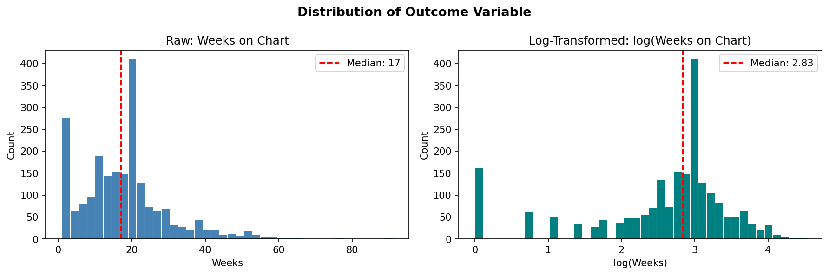
We see in the data that the number of weeks that a given song spends on the Billboard Hot 100 chart is right skewed. Given the skewness of the raw outcome, we log-transformed the dependent variable to satisfy OLS normality assumptions.

Figure X.X:
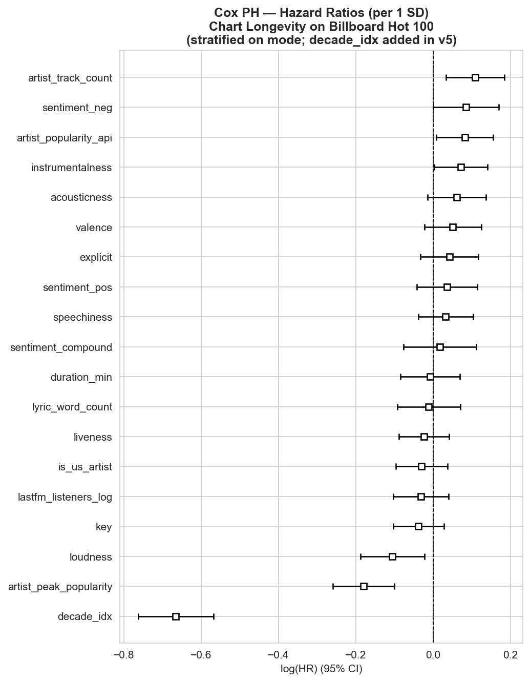

Table X.X: Cox PH Significant Coefficients
Feature | Coef | HR | p-value | Interpretation
decade_idx | -0.666 | 0.514 | <0.001 | 49% higher exit hazard per decade
artist_peak_popularity | -0.180 | 0.835 | <0.001 | Higher peak = longer runs
artist_track_count | +0.109 | 1.115 | 0.005 | Larger catalog = shorter runs
artist_popularity_api | +0.082 | 1.085 | 0.030 | Current popularity sustains chart
loudness | -0.106 | 0.900 | 0.012 | Louder = longer chart runs
instrumentalness | +0.071 | 1.074 | 0.043 | Instrumental = exits faster
HR = hazard ratio. HR > 1 indicates faster exit from chart (shorter run); HR < 1 indicates slower exit (longer run). Mode handled by stratification.

We ran multiple regressions based on our hypotheses.

Model 1: Audio features only

Figure X: Model output for regression of chart longevity on audio features

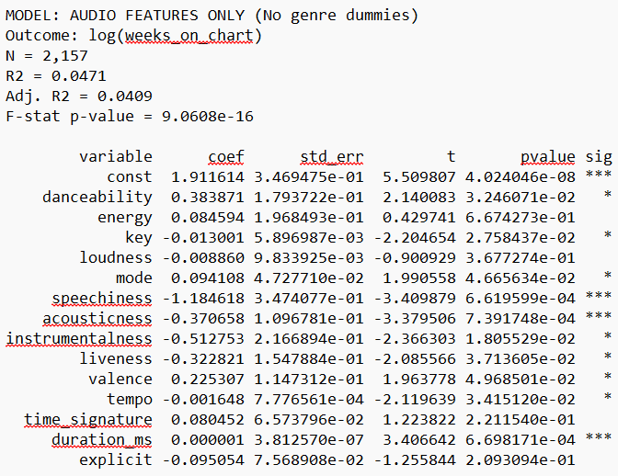

Audio features alone explain only about 5% of the variation in log(weeks on chart), with danceability, speechiness, acousticness, and duration among the significant predictors.

Model 2: Genre + audio features

Figure X: Model output for regression of chart longevity on audio features + genre

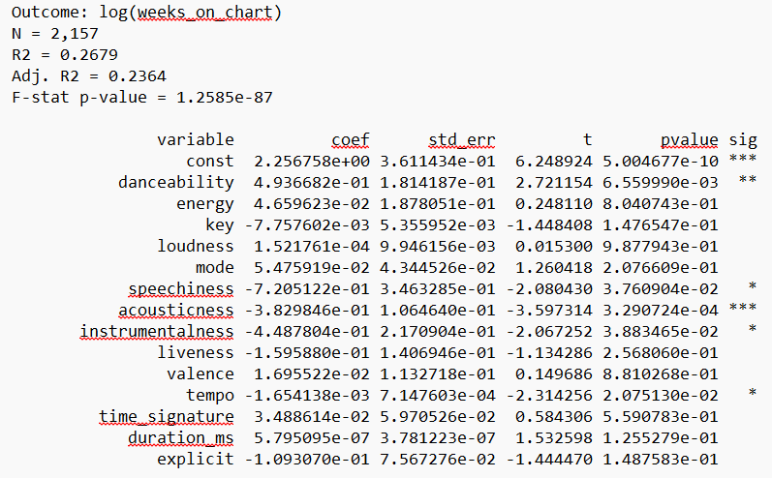

Note: 75 genres were left out of the regression output for space reasons.

Figure X: Effect of audio features on chart longevity (error bars = 95% CI; red = significant at p < 0.05)

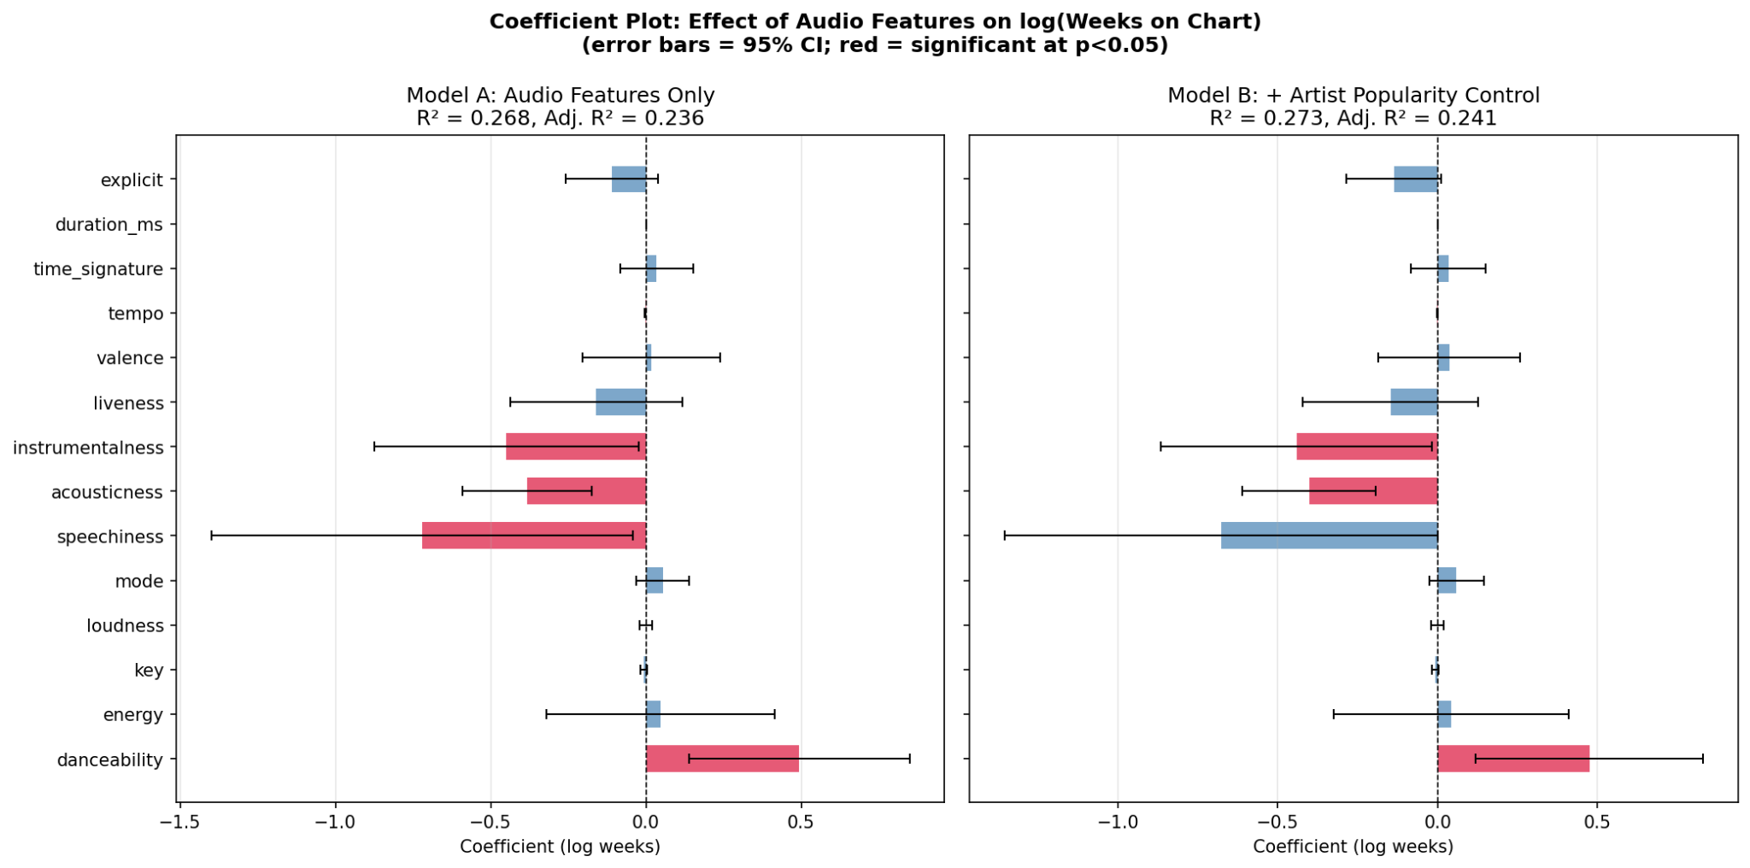
Adding genre dummies raises R² to about 27%, with genres like country and dance associated with longer chart life and club with shorter.

Model 3: Audio features + genre + artist controls

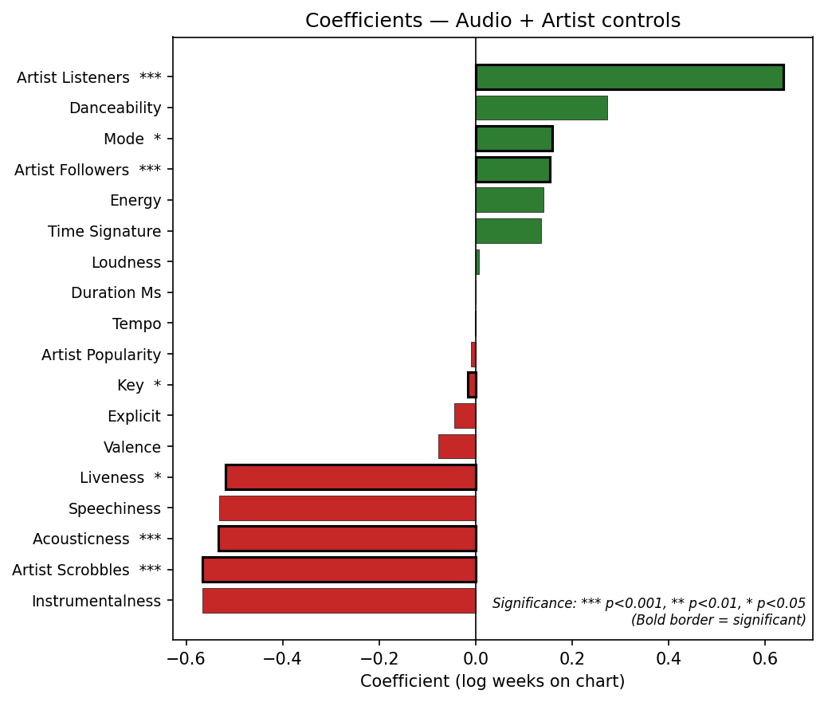

Including both artist controls and genre dummies pushes R² to about 23%, with artist and genre effects both significant.

Model 4: Audio features + genre + artist controls + sentiment/lyrics

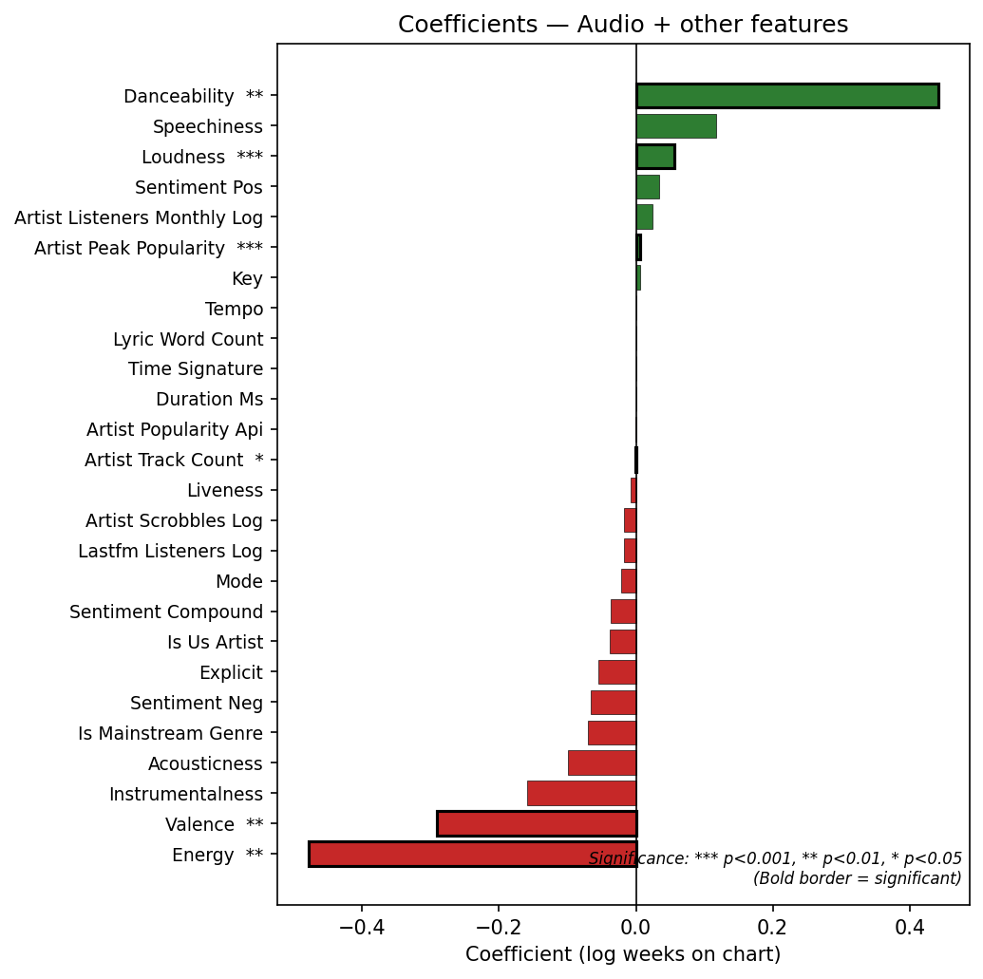

Using the full feature set (artist, metadata, sentiment, lyrics) on the subset with complete data yields R² of about 24%, with artist peak popularity and several audio features (e.g., loudness, valence) significant. Adding genre does not improve fit beyond the audio + other model (R² unchanged at about 24%).

Temporal Validation Model

Year | Sample | Model | R-squared (Train) | R-squared (Test)
2015 | Train N=1633, Test N=524 | Model 1 (Audio only) | 0.055 | -0.057
2015 | Train N=367, Test N=145 | Model 2 (Audio + other) | 0.363 | -0.404
2015 | Train N=367, Test N=145 | Model 3 (Audio + other + genre) | 0.479 | -0.323
2019 | Train N=1867, Test N=290 | Model 1 (Audio only) | 0.066 | -0.119
2019 | Train N=446, Test N=66 | Model 2 (Audio + other) | 0.324 | -0.103
2019 | Train N=446, Test N=66 | Model 3 (Audio + other + genre) | 0.452 | -0.105

For all three model types (audio only, audio + other, audio + other + genre), out-of-time R² on 2015+ data is negative, so predictions are worse than using the test-period mean. The same pattern holds for 2019, indicating that this is not a matter of recency bias.

